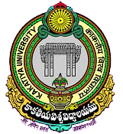
Office of the Principal
University College of Commerce & Business Management
Kakatiya University, Warangal–506009, Telangana

Post-Doctoral Fellows of the Department

No. | Name of the PDF | Awarder | Year
 | Dr. B. Prasad | UGC | 2008
 | Dr. O. Ravinder | ICSSR | 2009
 | Dr. B. Parashuramulu | ICSSR | 2016
 | Dr. Ch. Srikanth Verma | ICSSR | 2016
 | Dr. Ch. Suresh Chandra | UGC | 2016
 | Dr. G. Surendar | UGC | 2016
 | Dr. E. Sreenu | UGC | 2016
 | Dr. K. V. L. Manasa | ICSSR | 2017
 | Dr. G. Srinivas Reddy | ICSSR | 2019
 | Dr. A. Yakaiah | ICSSR | 2019
 | Dr. D. Veena | ICSSR | 2019
 | Dr. B. Jain Singh | ICSSR | 2022

